**Bookmaker Analysis Document**

**Searching Parameters to be focused:**

* Sport
* Country
* League
* Bet Type Category
* Bet Type
* Bet Sub Type

**Note:** we left some leagues with name of “winner, outright, in play, run of play, players”

Scenario 1: If we found keyword "All market" in bet type category, no need to fill it.

Scenario 2: Bet Victor example => Bet Sub Type: Everton 1-0

Here this will apply on Over/Under scenarios. Where Over/under will be on the header column and actual number like 0.5, 1.5 etc will be in place of sub bet type.

**Bookmaker List:**

Marathon:

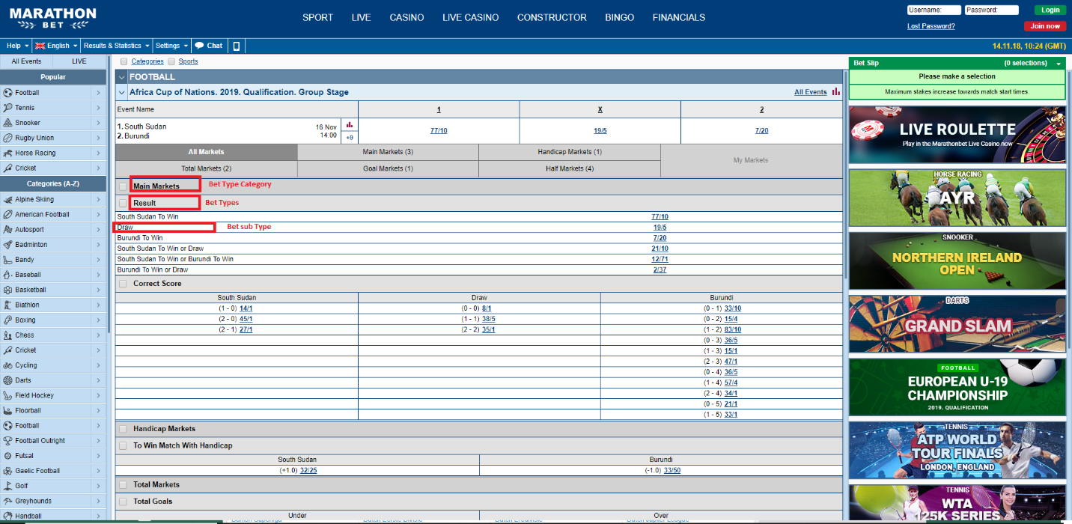

Bet Victor

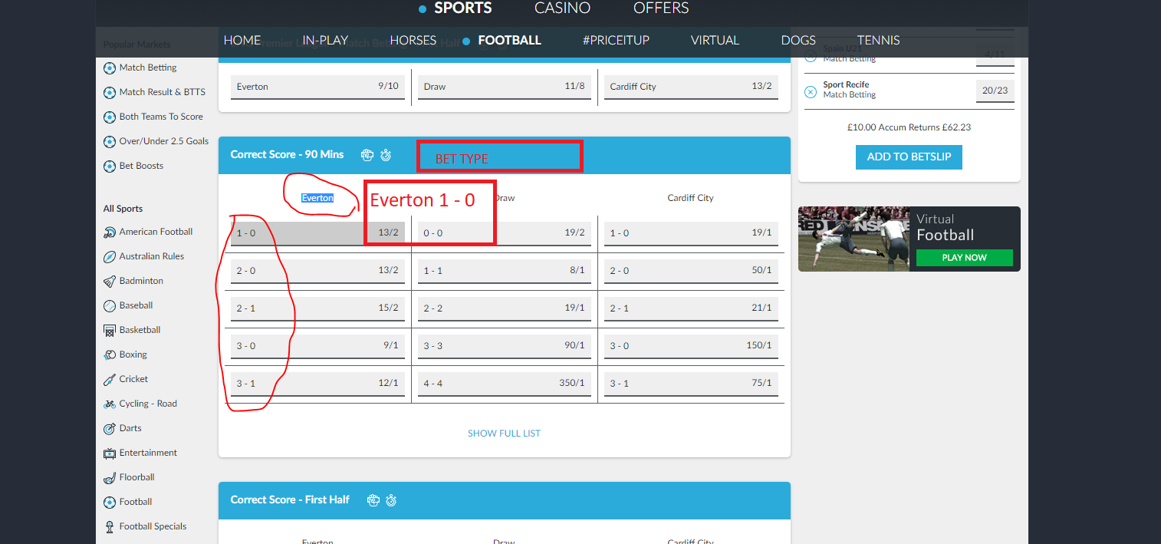

Coral:

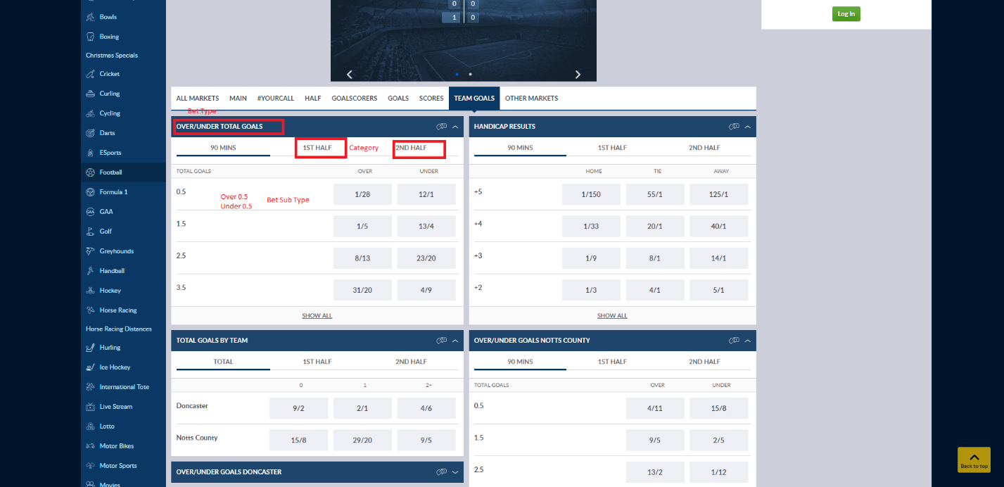

Paddy Power:

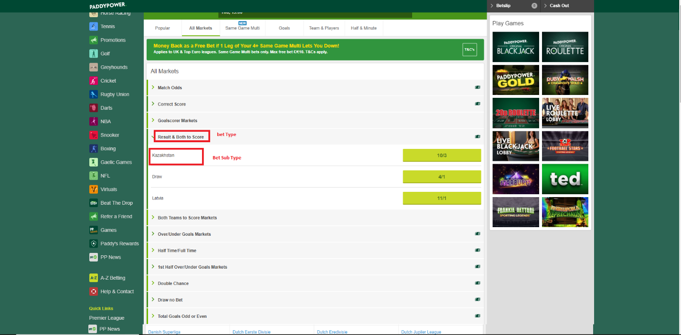

10 Bet:

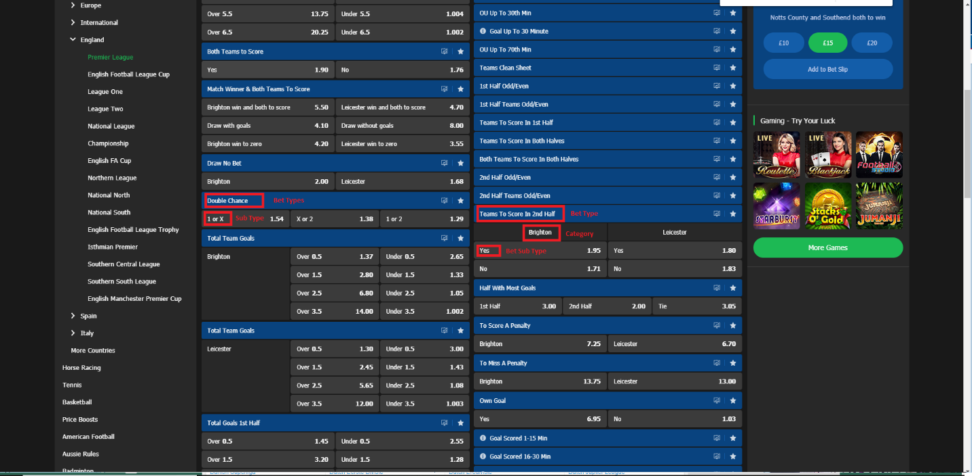

Unibet:

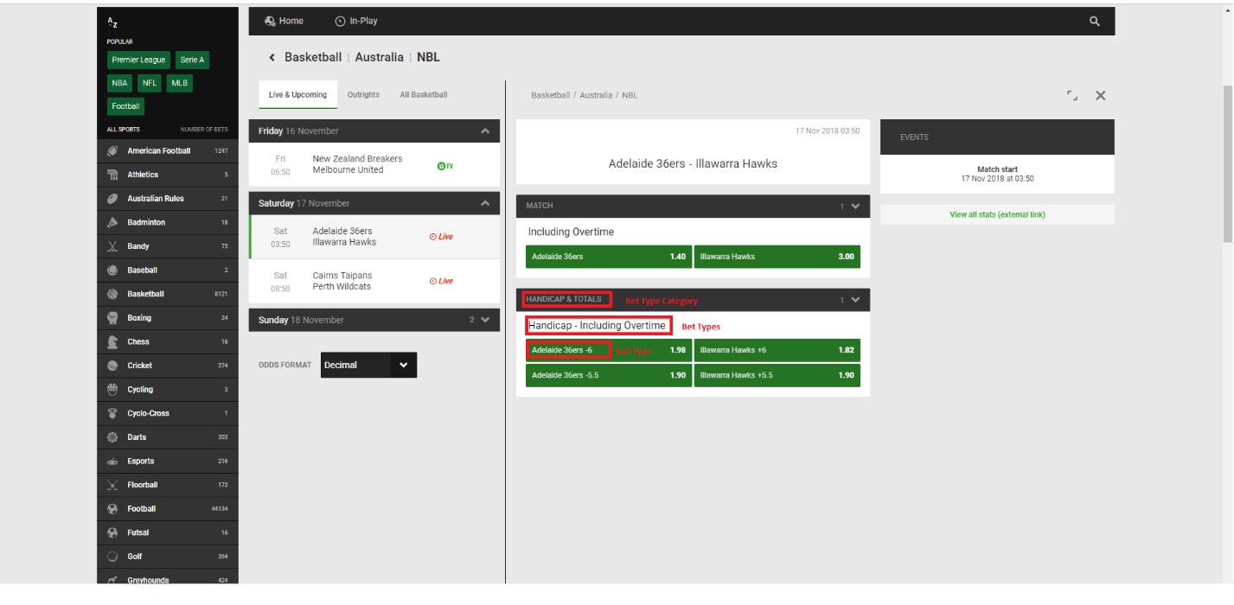

32 Red bet:

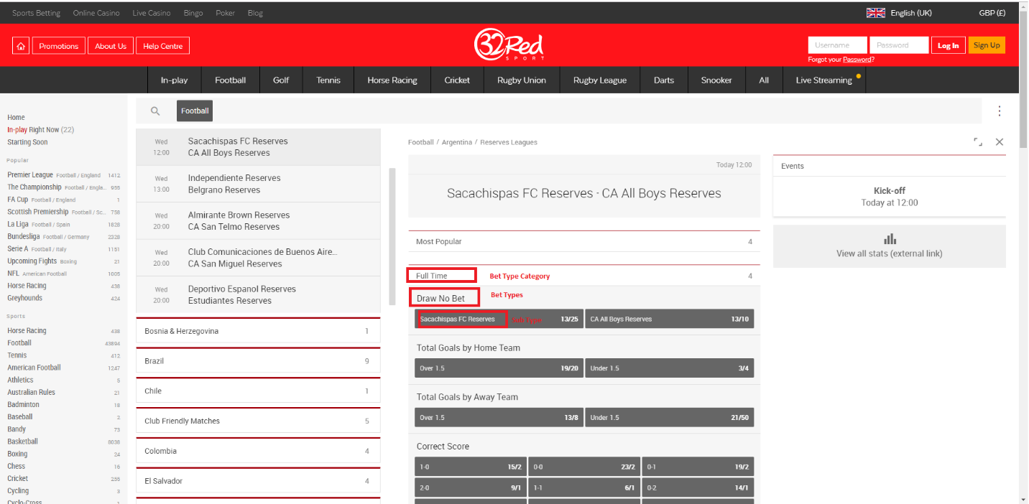

188Bet:

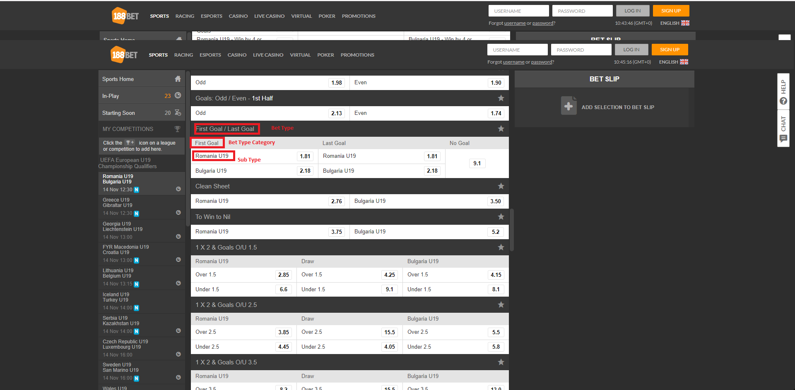

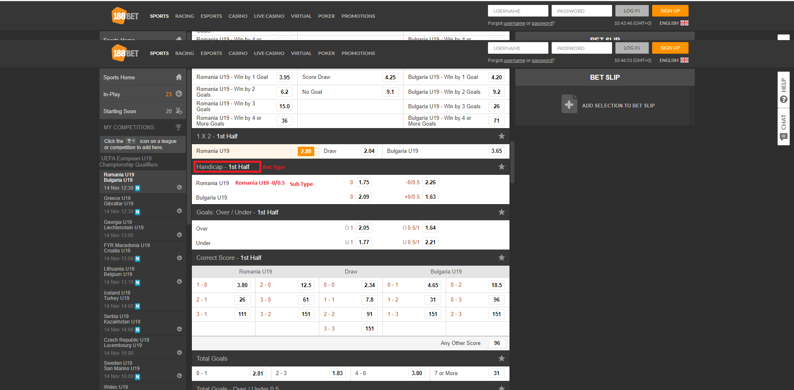

William Hill:

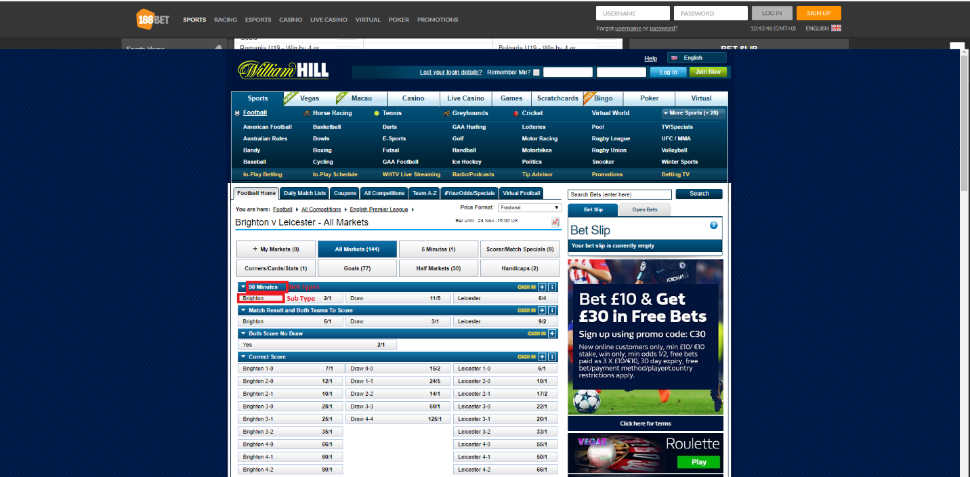

Bwin:

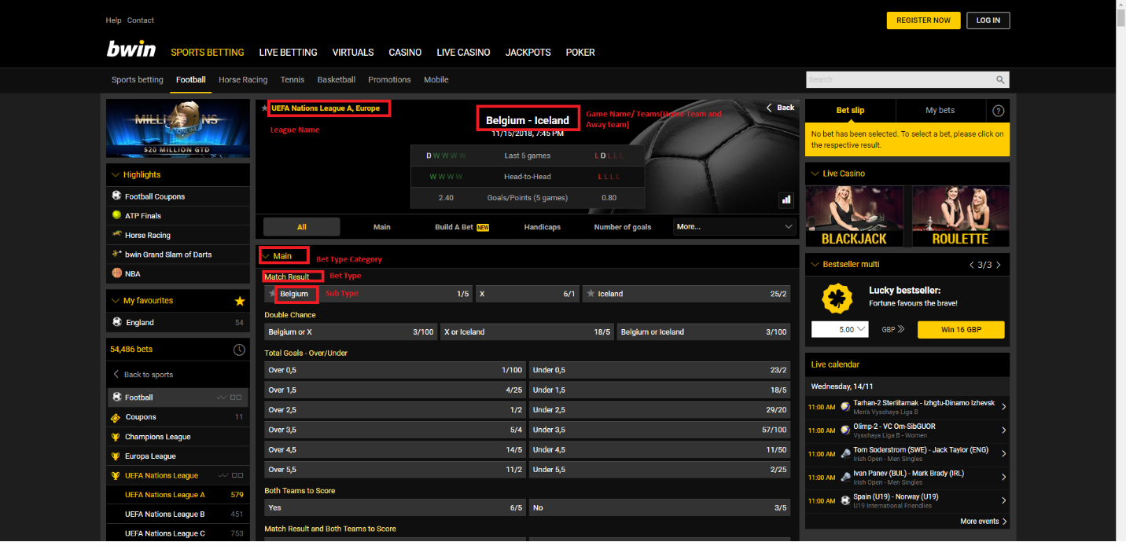

Betway:

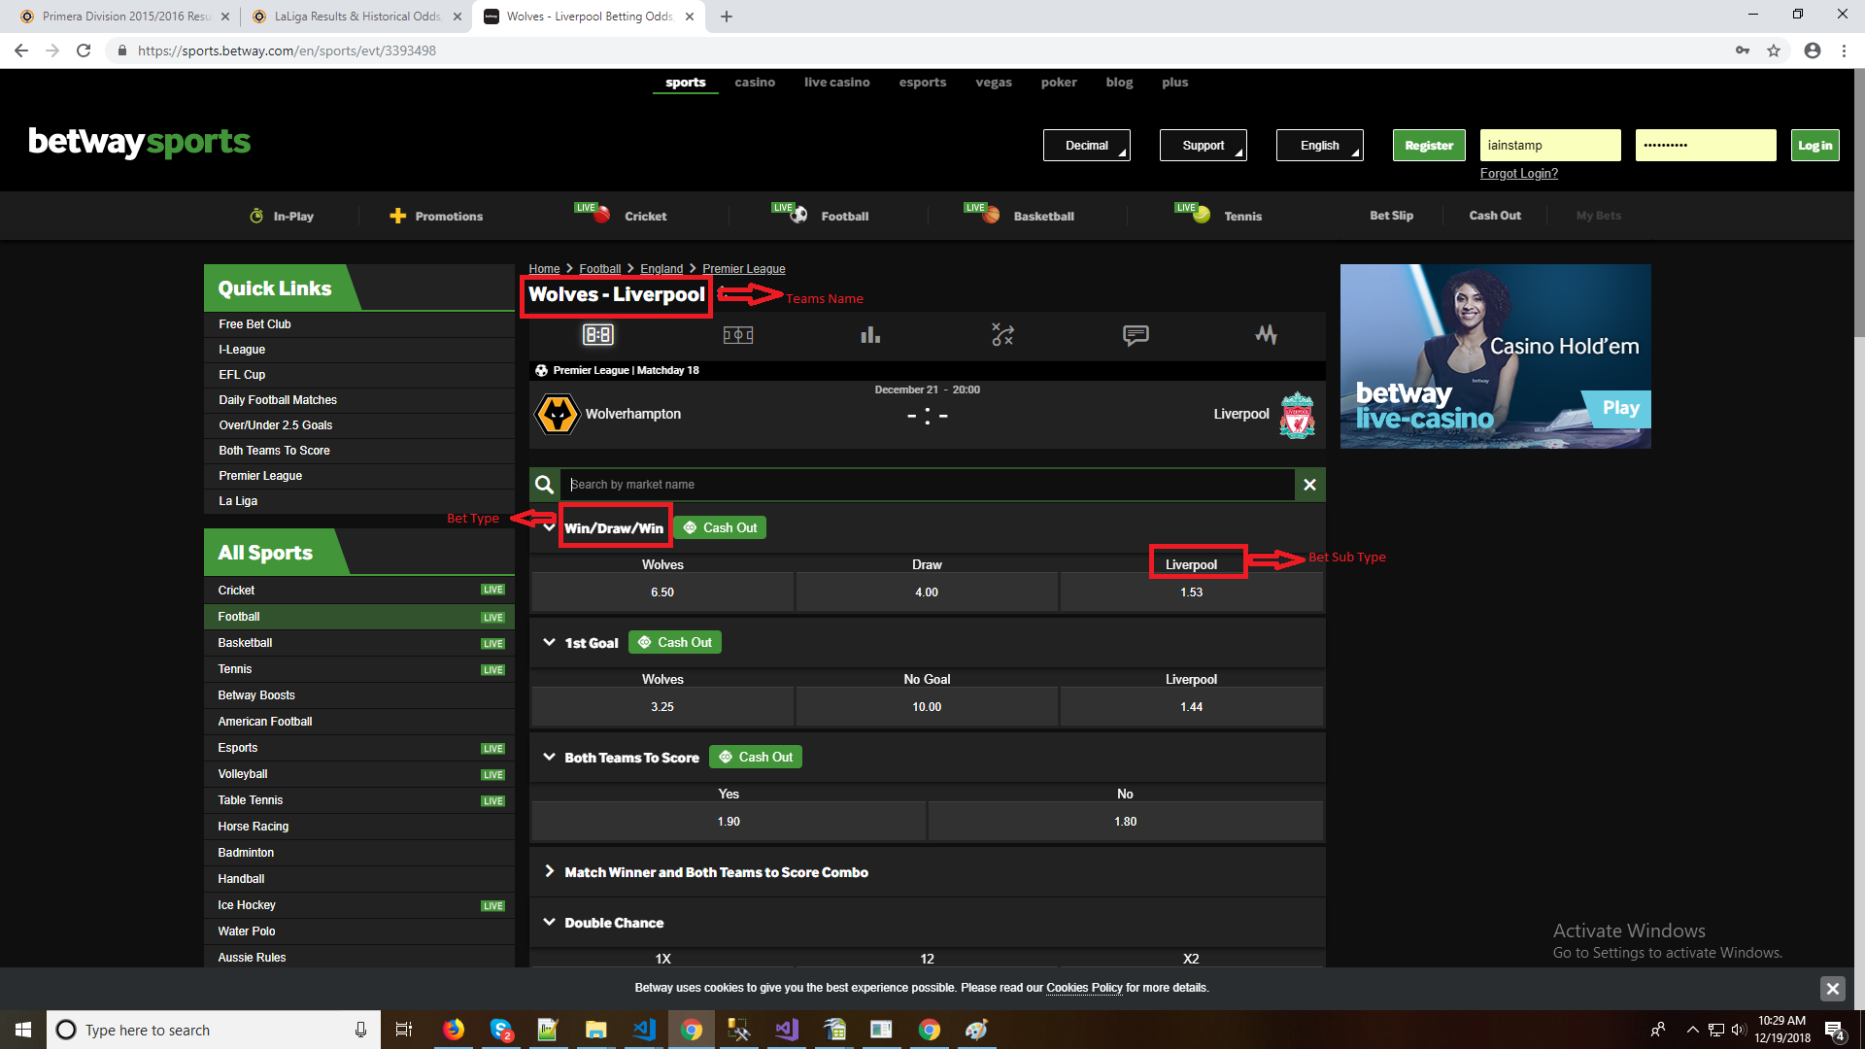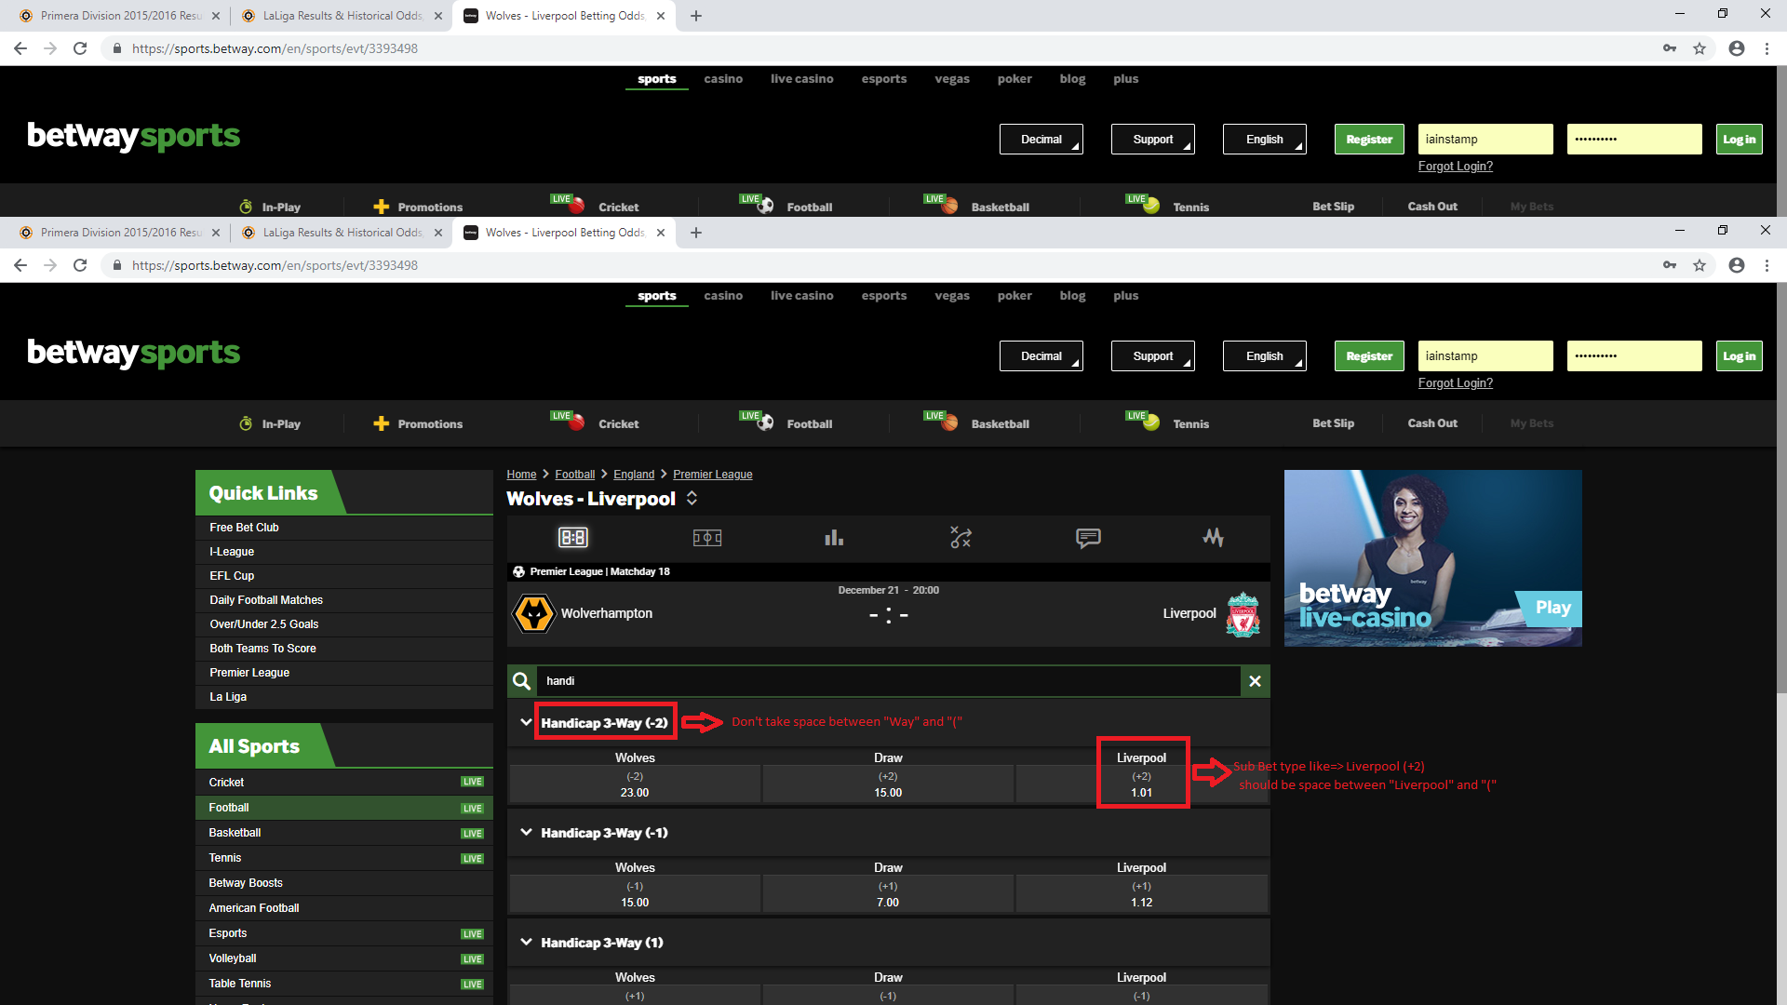

Bet365:

we only require to have Team Name and we will apply search on Team A or Team B .And select the desired match for particular sports .

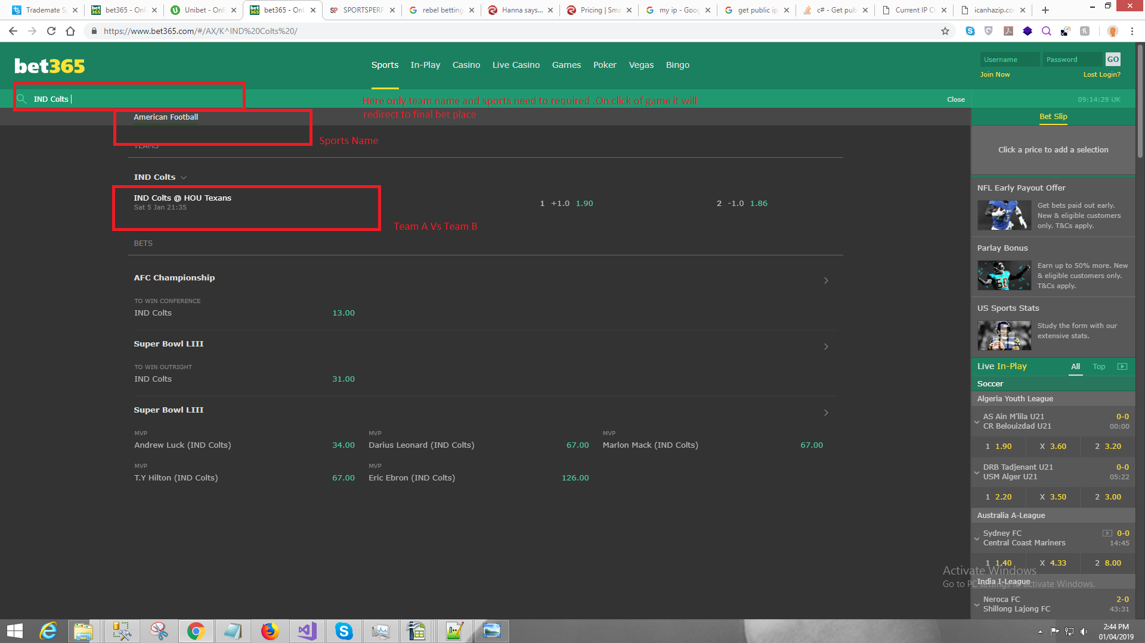

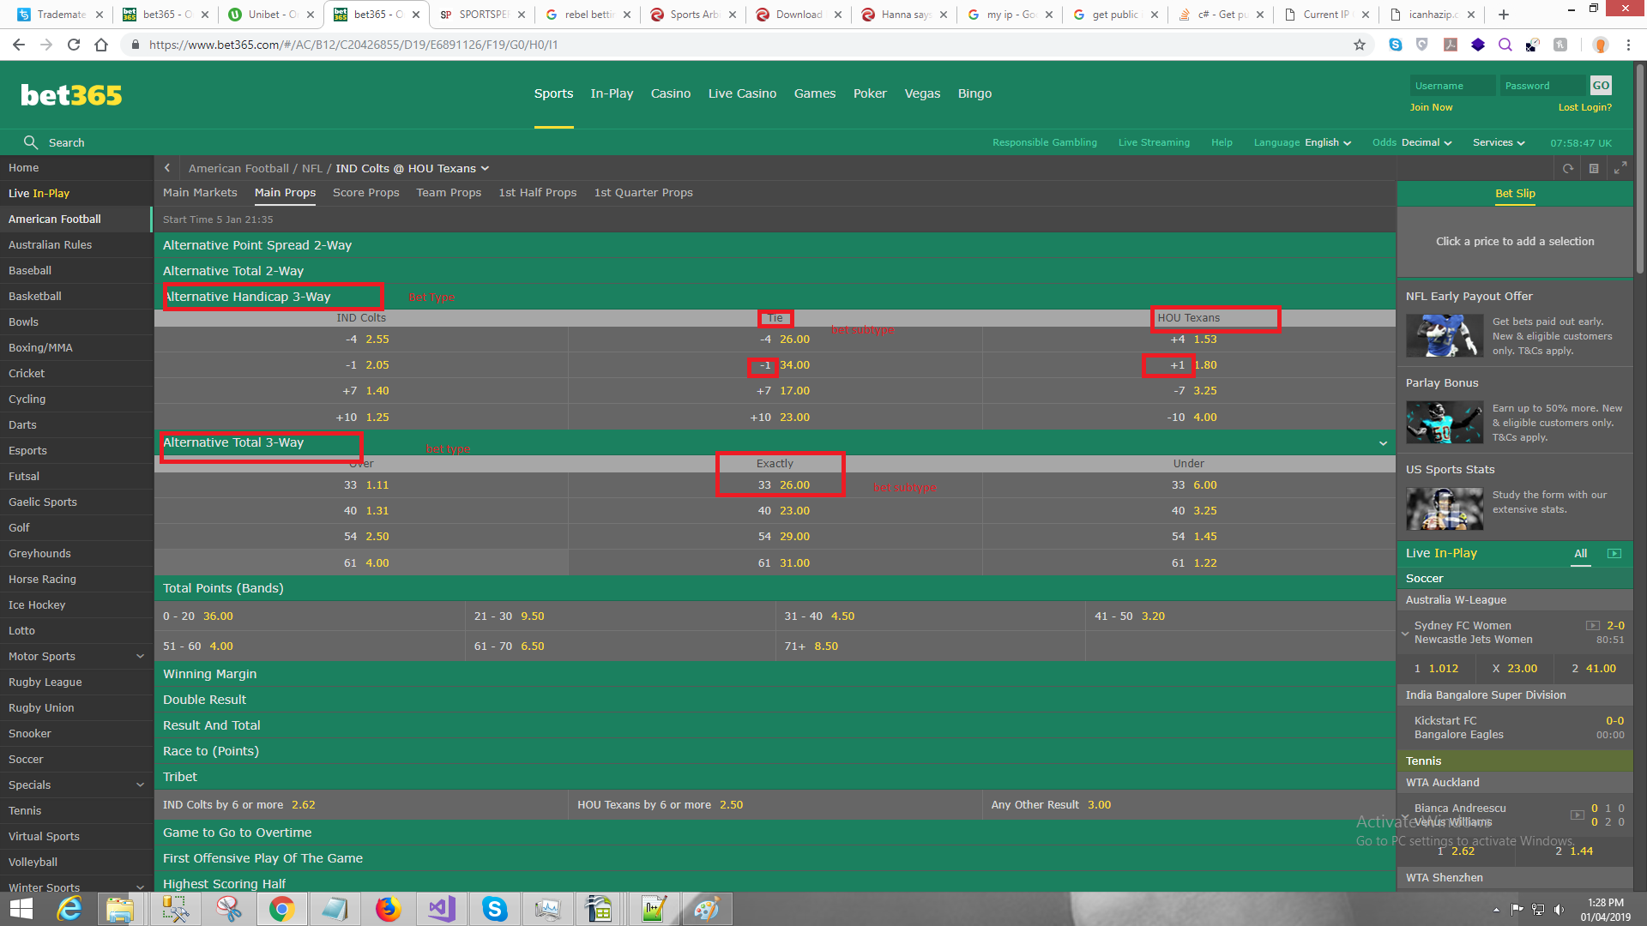

We will have category for GameBetting/MainMarket

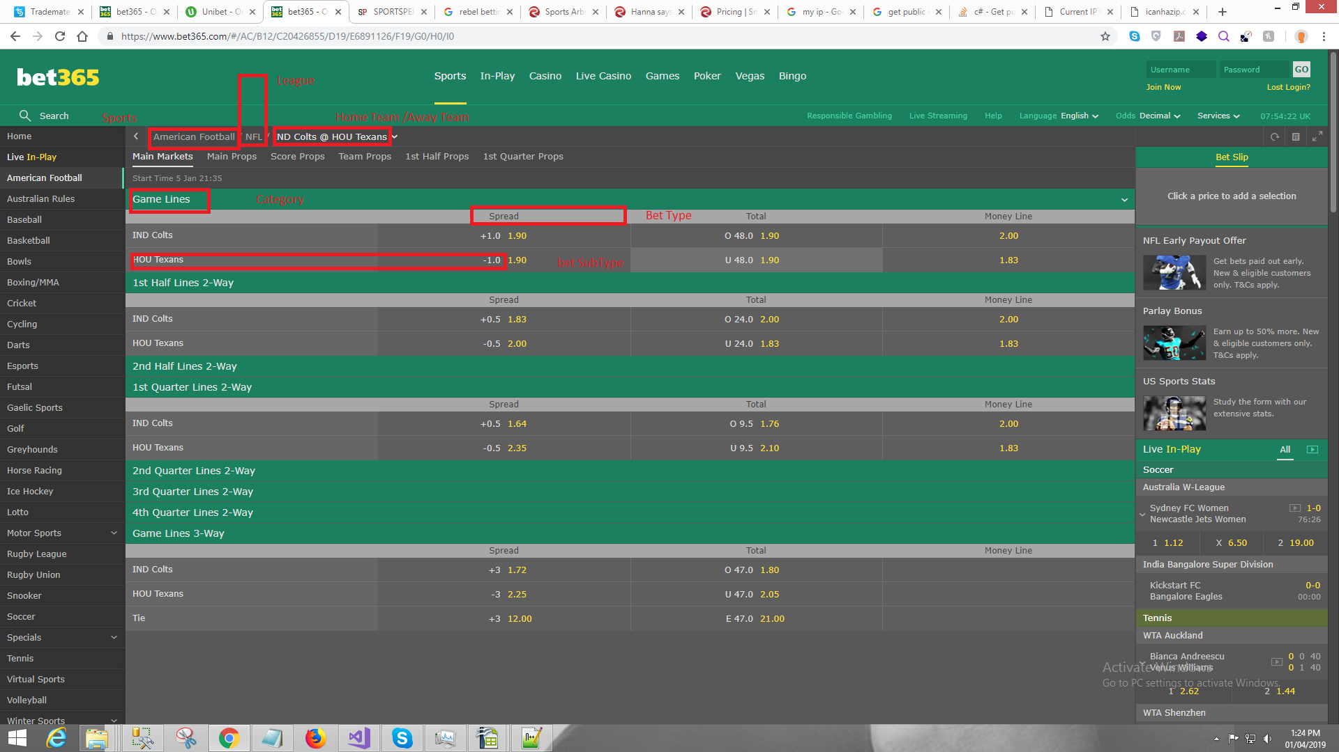

**_888:**

Category are mandatory for 888 scraper.

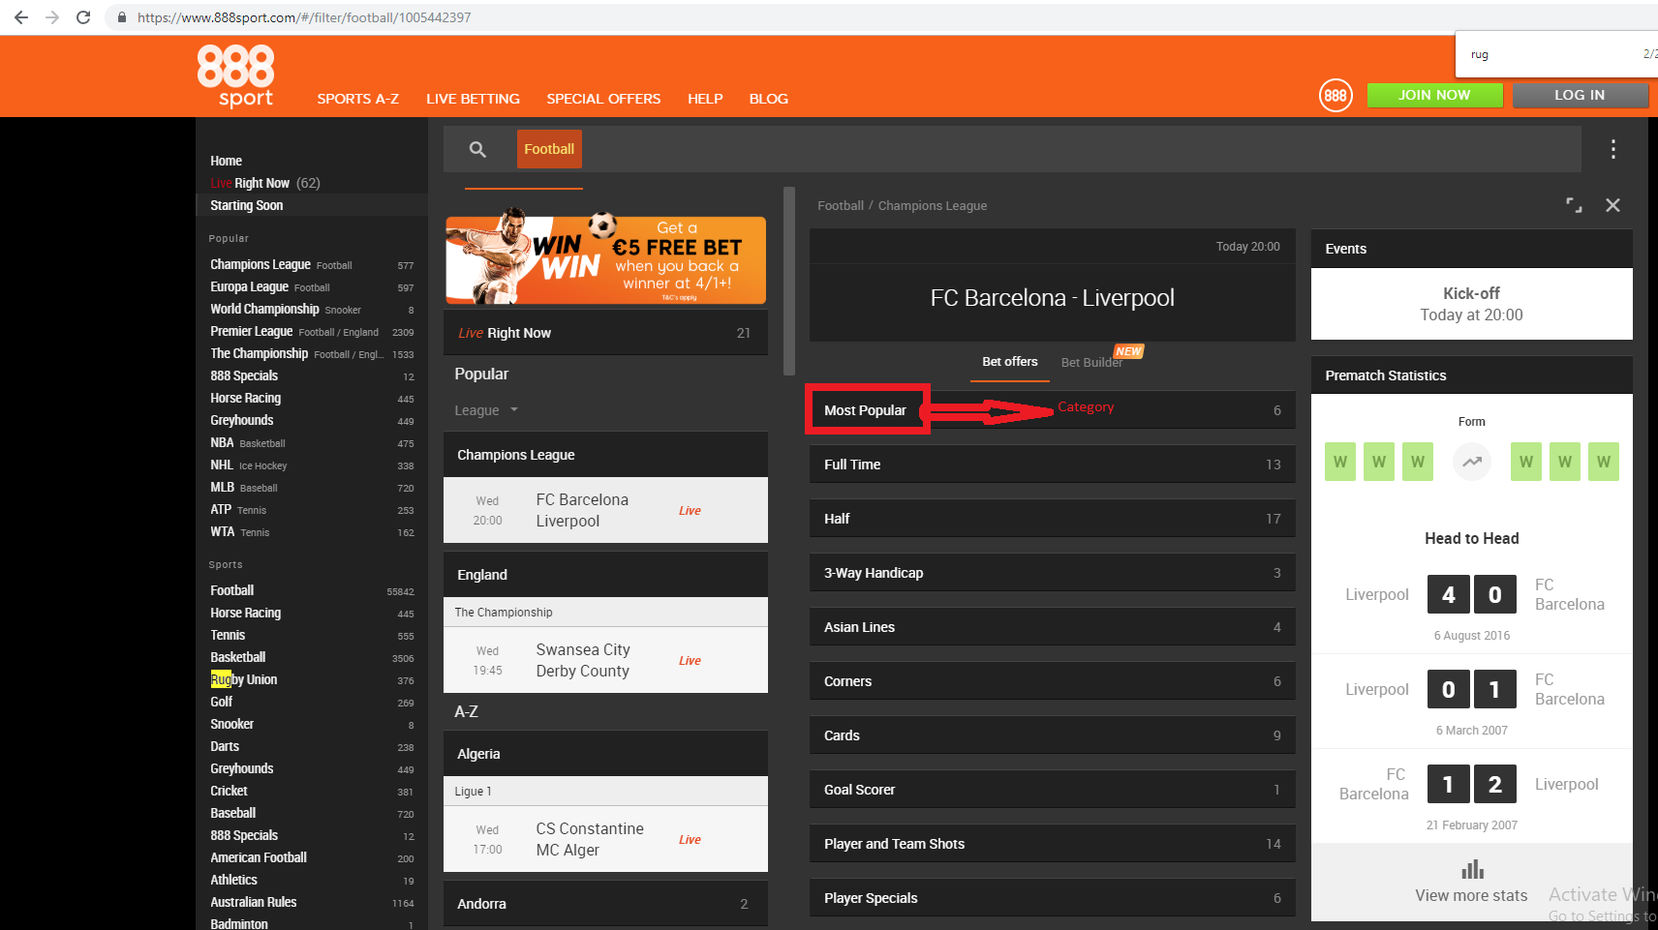

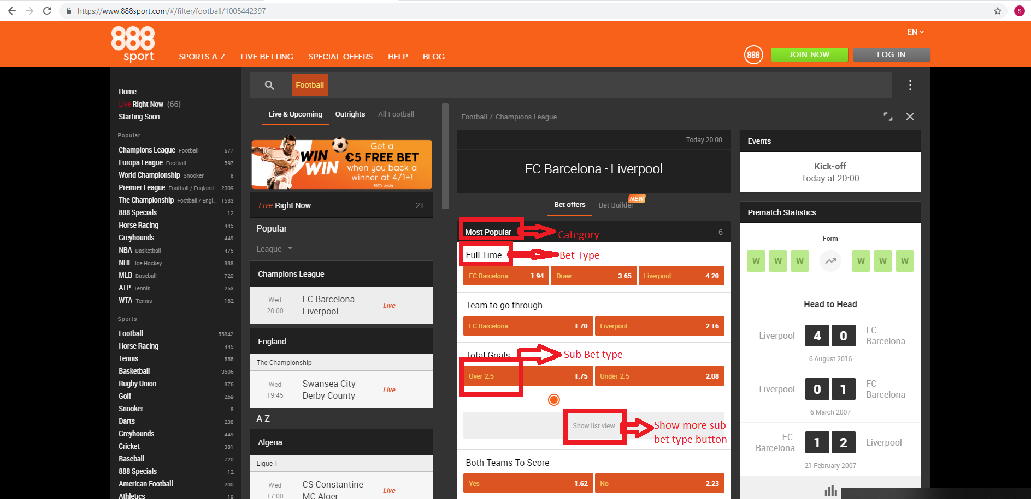

**BetFred :**

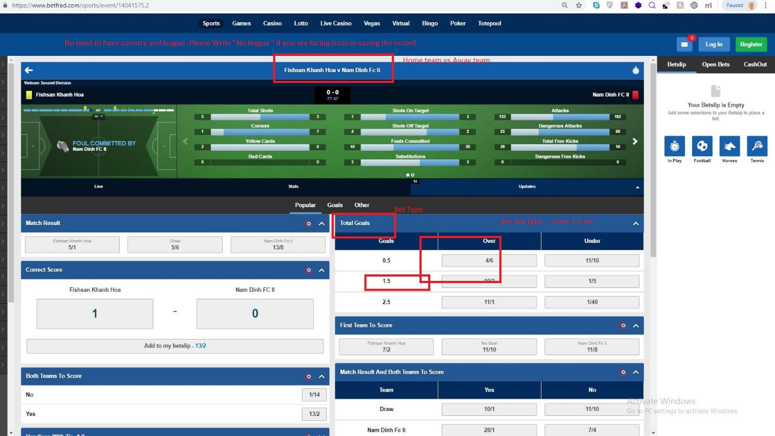

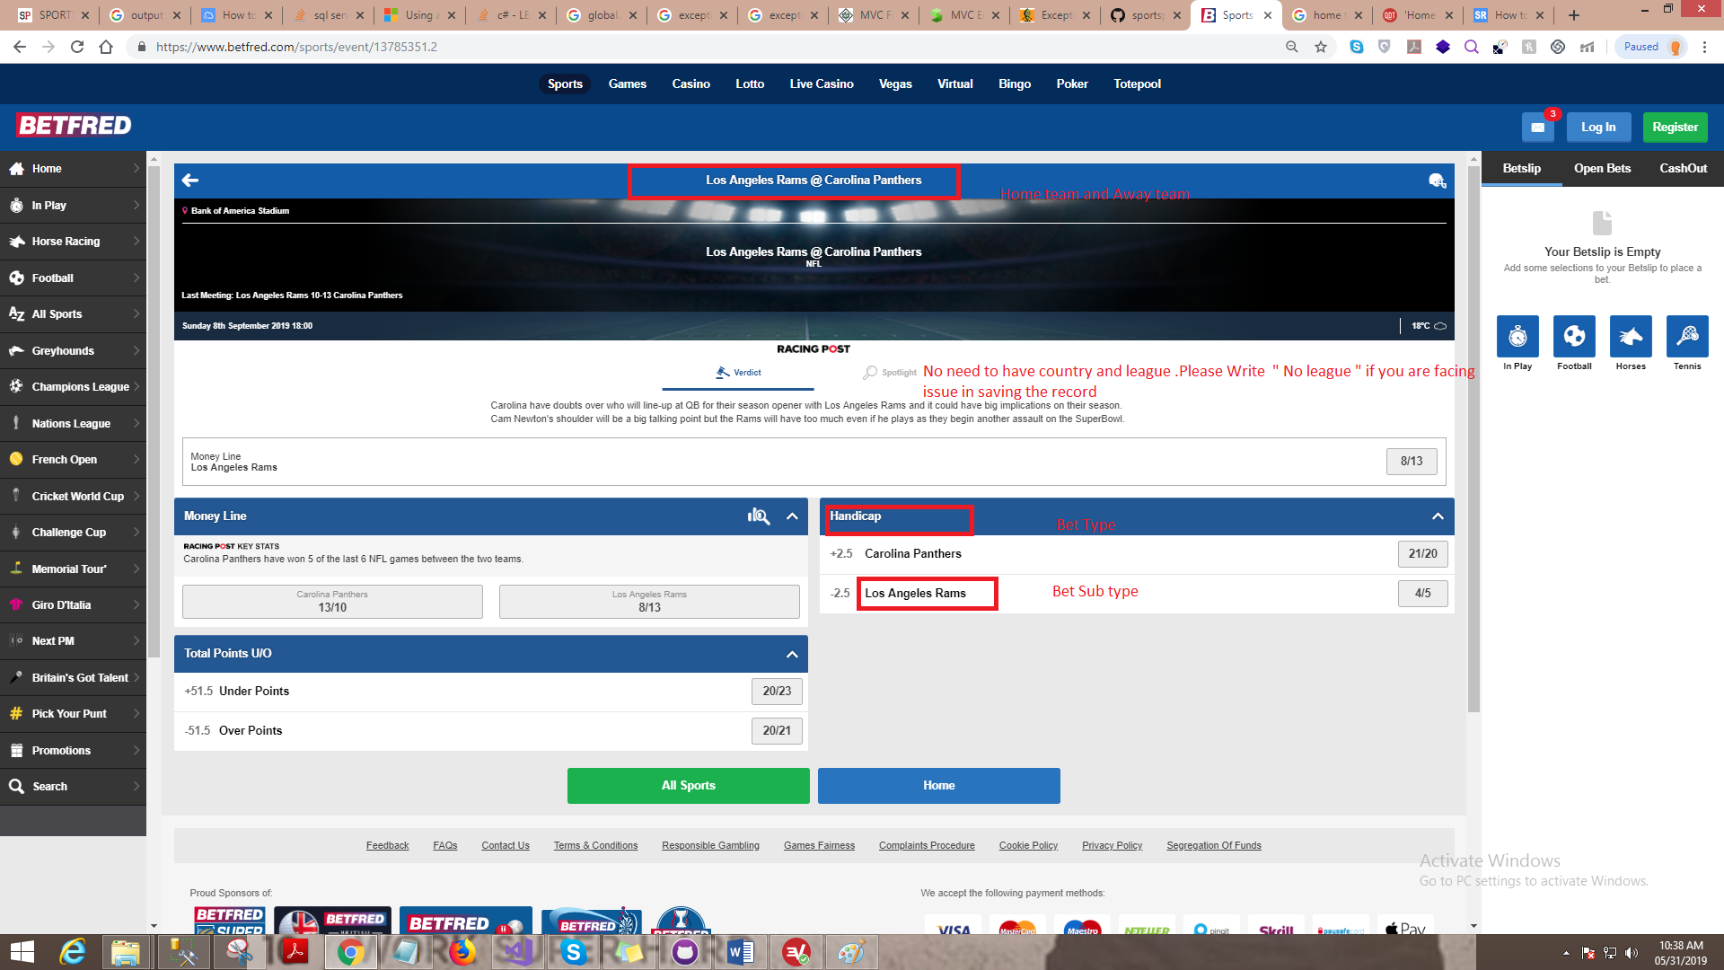

**LADBROKES :**

**Category** **are mandatory** for Ladbrokes.

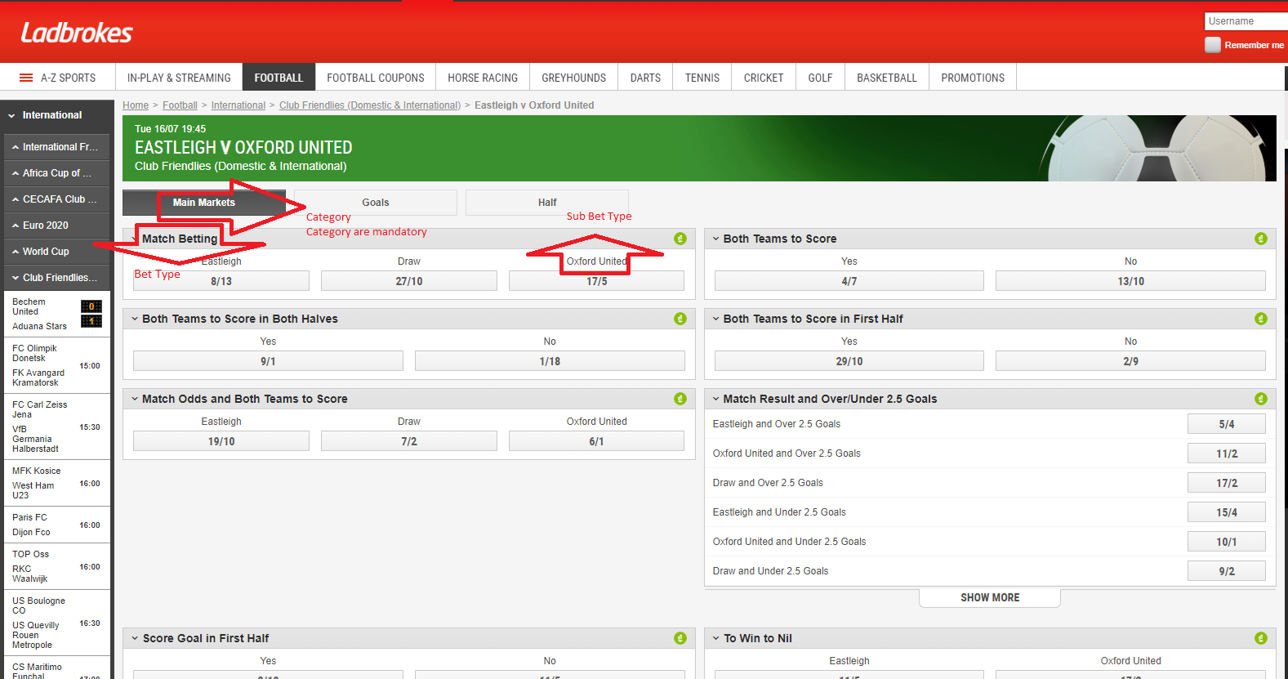

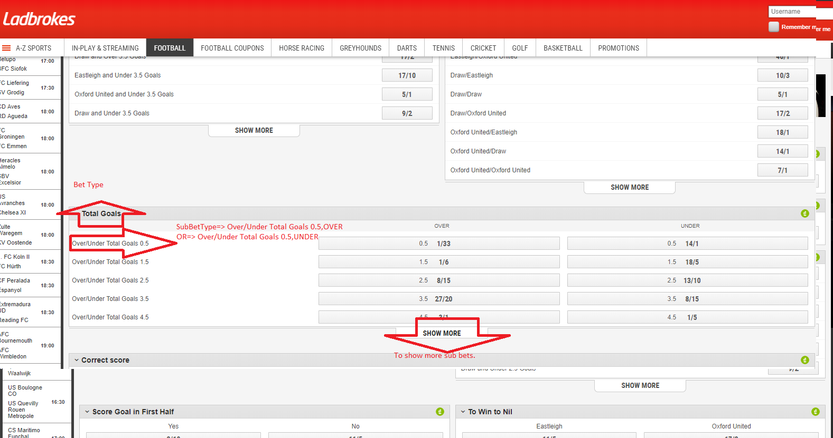

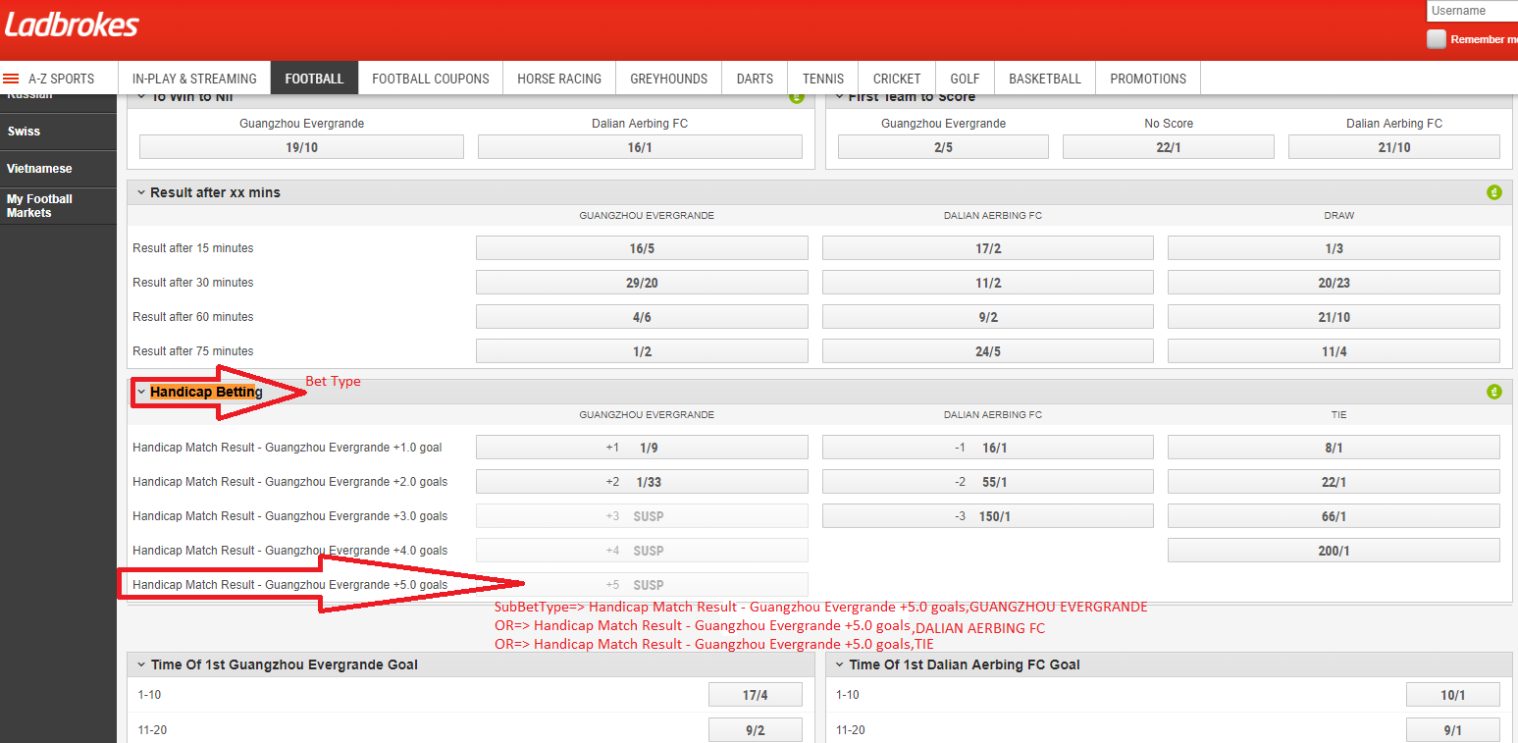

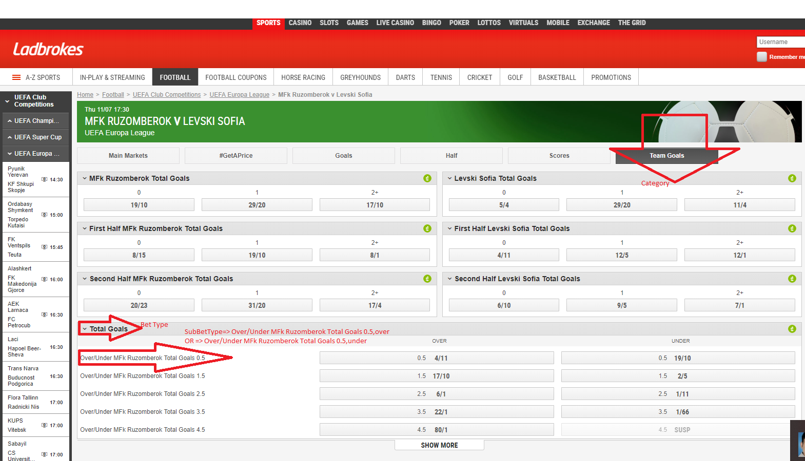

**BetClic :**

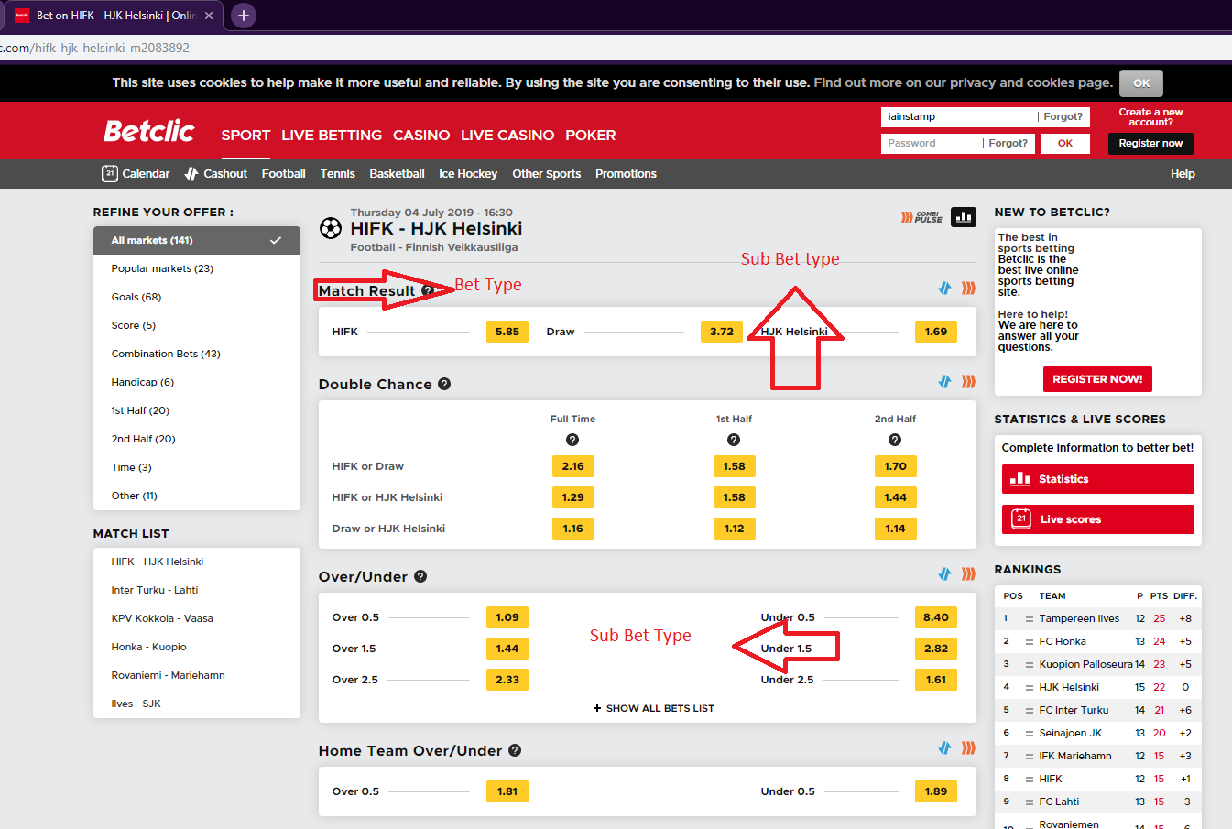

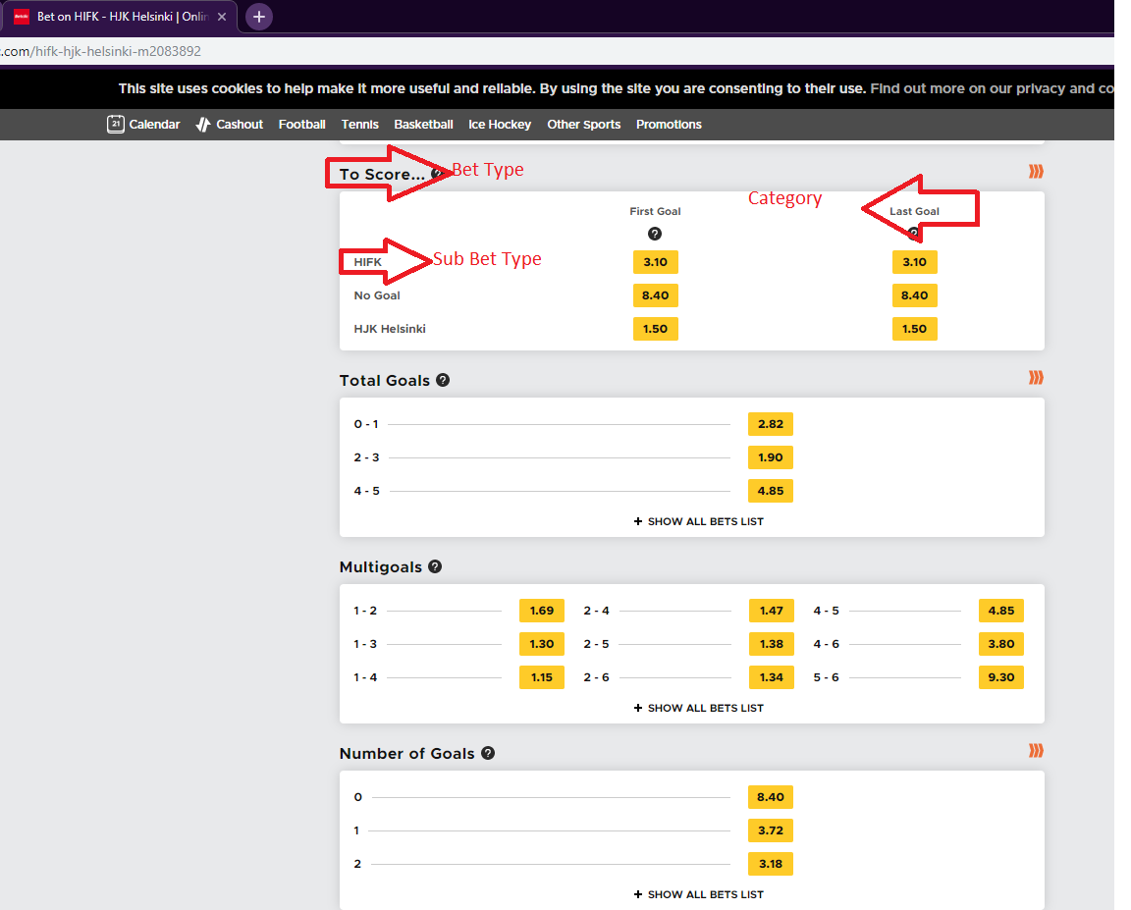

**Expekt :**

